**Lesson07 App Service Logs**

**Notes: -**

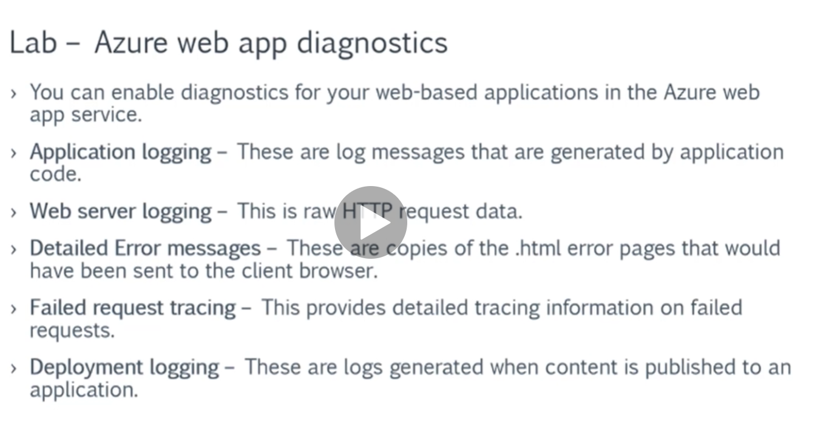

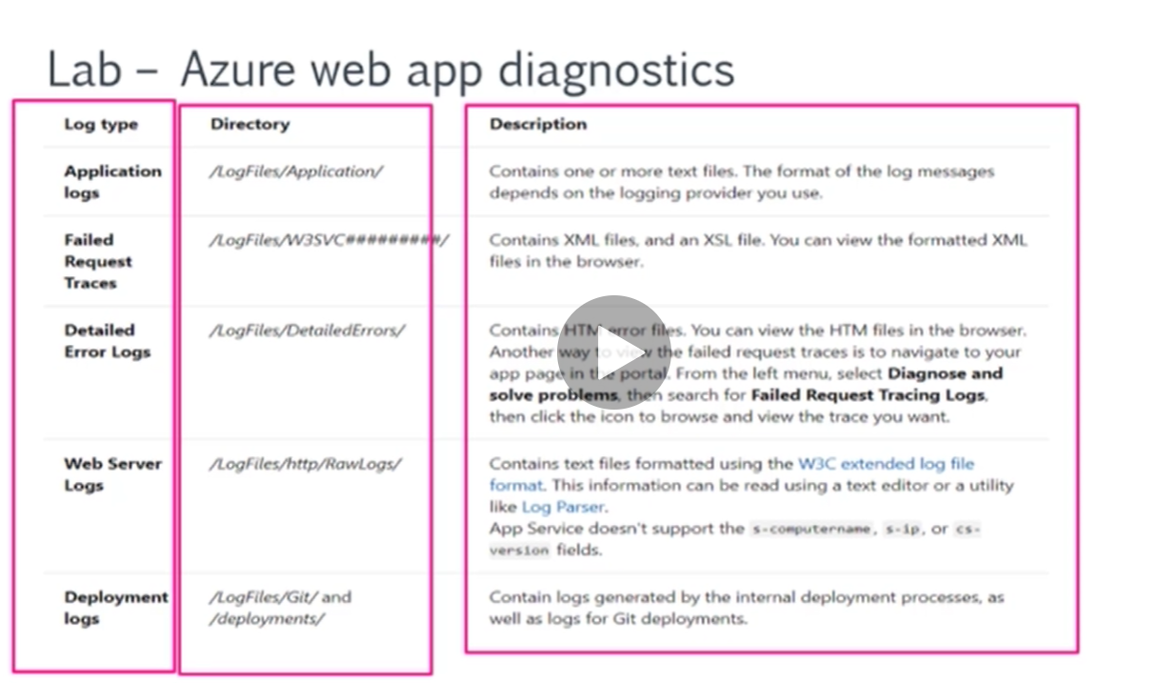

**Steps:-**

**1-on project > Index.cshtml.cs (we apply diagnostics on Index code behind)**

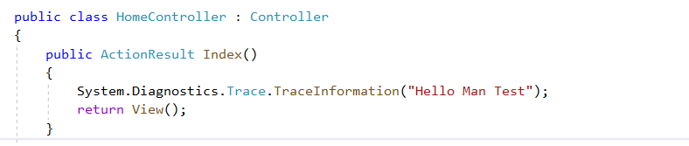

2-on azure portal > web app > we select Linux app service > and select app service plan

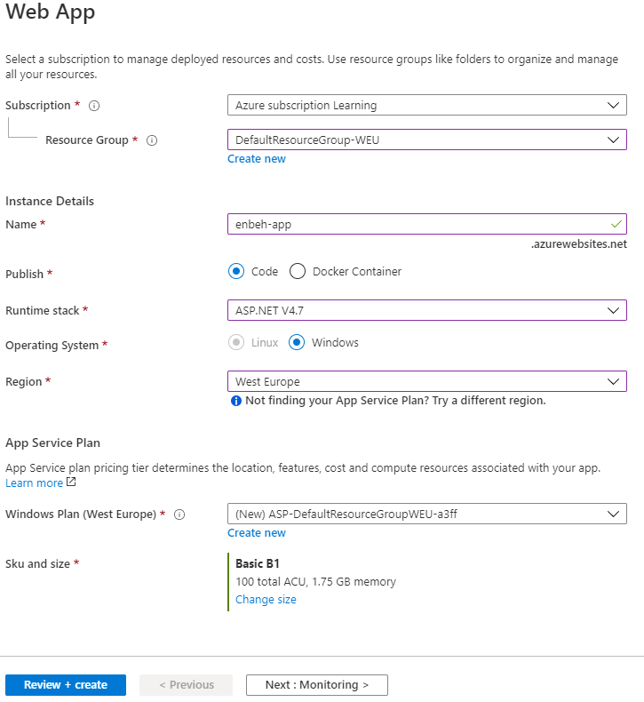

**3-on Azure App Service > Monitor > App Service Logs**

**(we see that if you create app service in .net framework you see that there are different types of logging appeared as below)**

**(we chosoe application insight (file system) and web server logging (file system))**

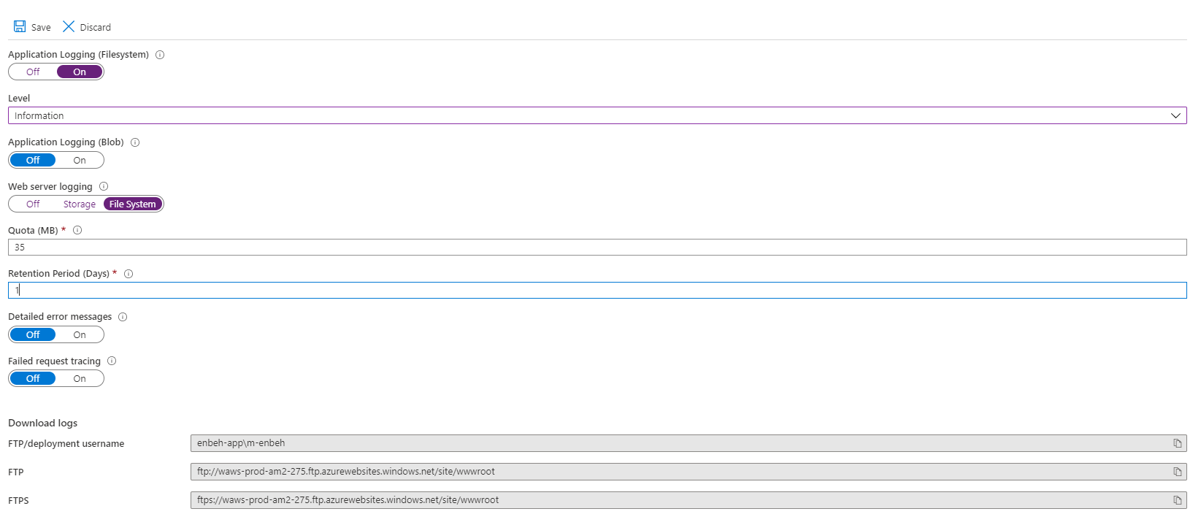

**4-on VS2019 we apply publish to azure app service Linux O.S**

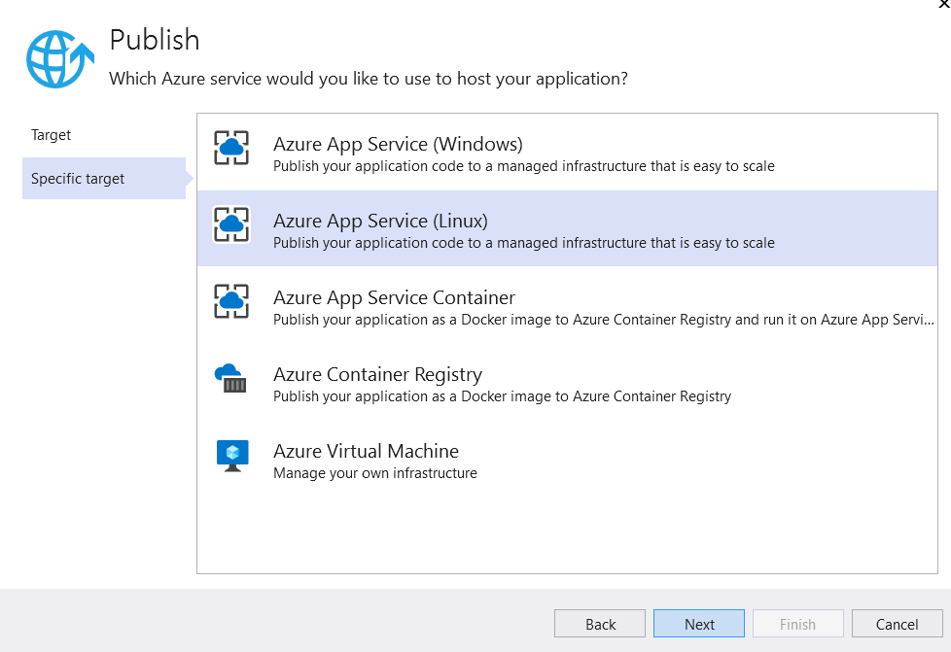

**(In order to access to app service through winscp , we have to make access permission through the FTP Deployment center)**

**5-on azure portal > Deployment Center > FTP**

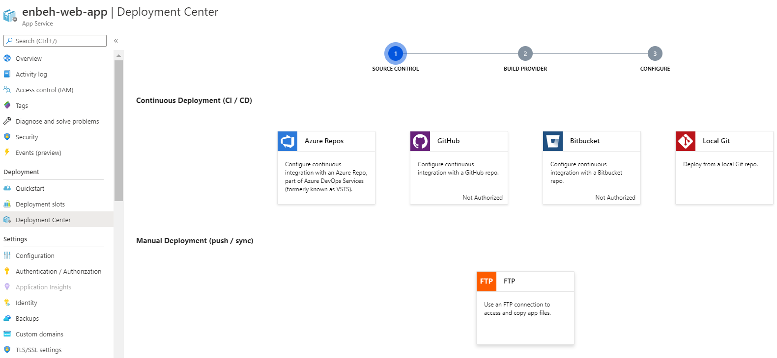

**6-we set the user credential (username and password)**

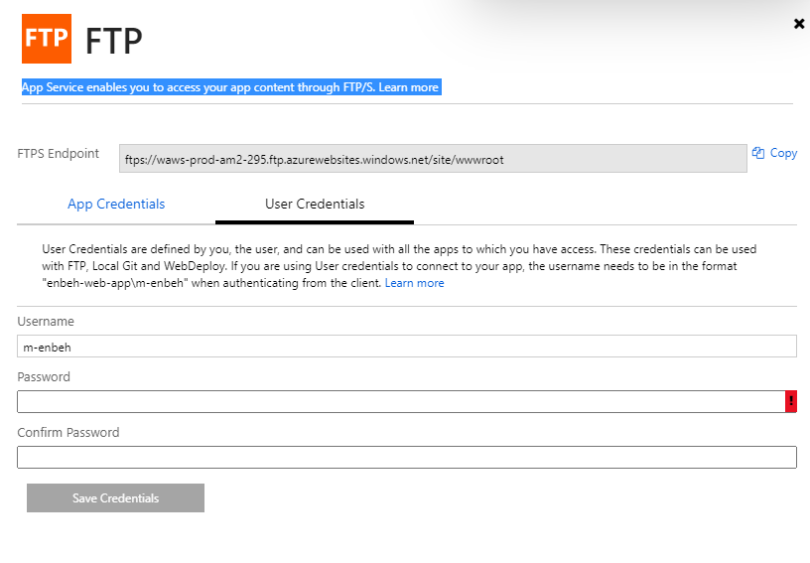

**7-on winscp we take the enbhe-web-app\m.enbeh as username and the Ftp Endpoints as host name to access the app service through FTP**

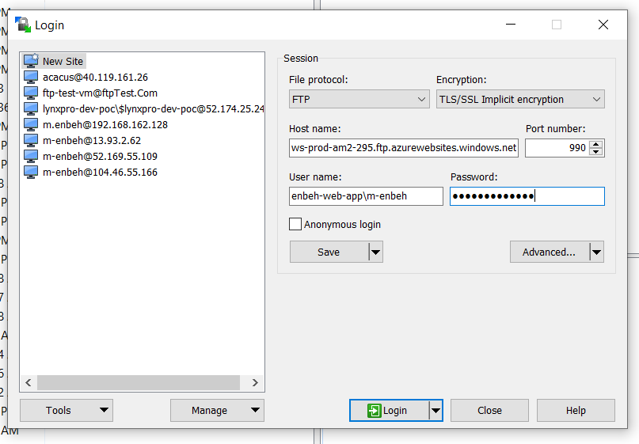

**8-we see that when navigate between pages in .net app service , that logging are added inside the path of root/LogFiles/Applications/logfilename**

